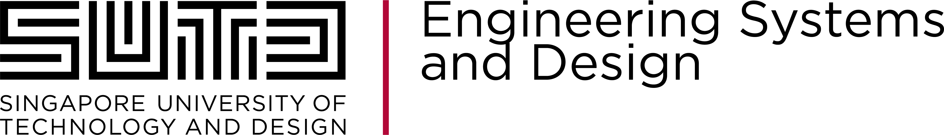

**ESD - 40.014: Engineering Systems Architecture**

Term 5 2021

Team Number: **12**

Team Name: **Magic Hunter**

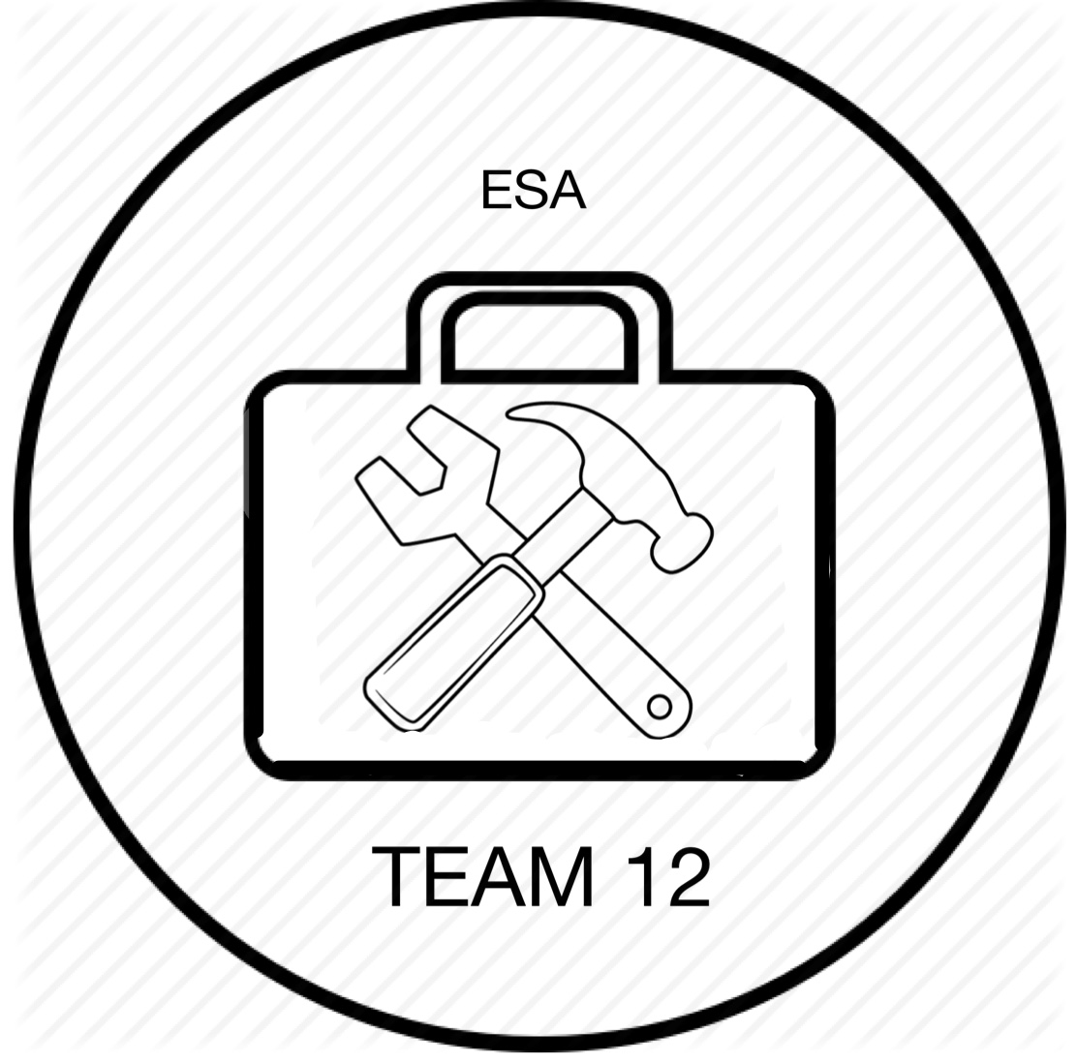

Team Members:

Ian Tay Rui-Ming, Ang Kang Xian, Chan Kian Quan, Wu Xin Yun [From left to right]

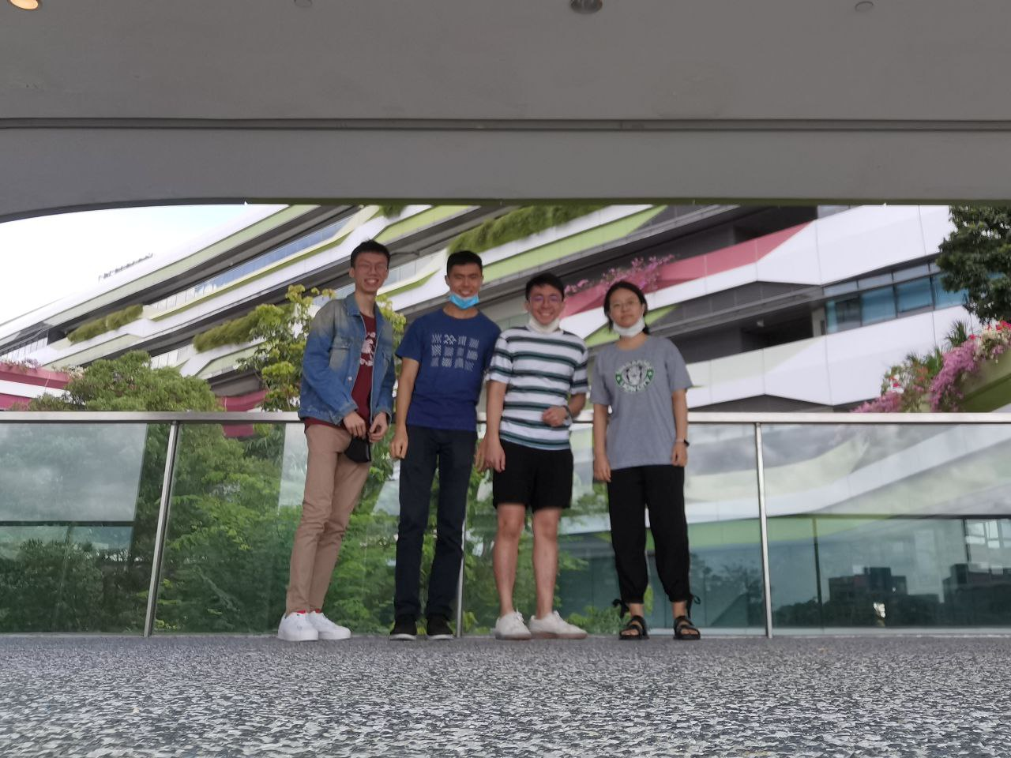

Submission Date: 26/03/2021

Project Theme: Job Finding Game